Lab Assignment – Data Visualization Exercise I

Shaun Pritchard

Rasmussen College

QMB4100

Darice Corey

April 11, 2021

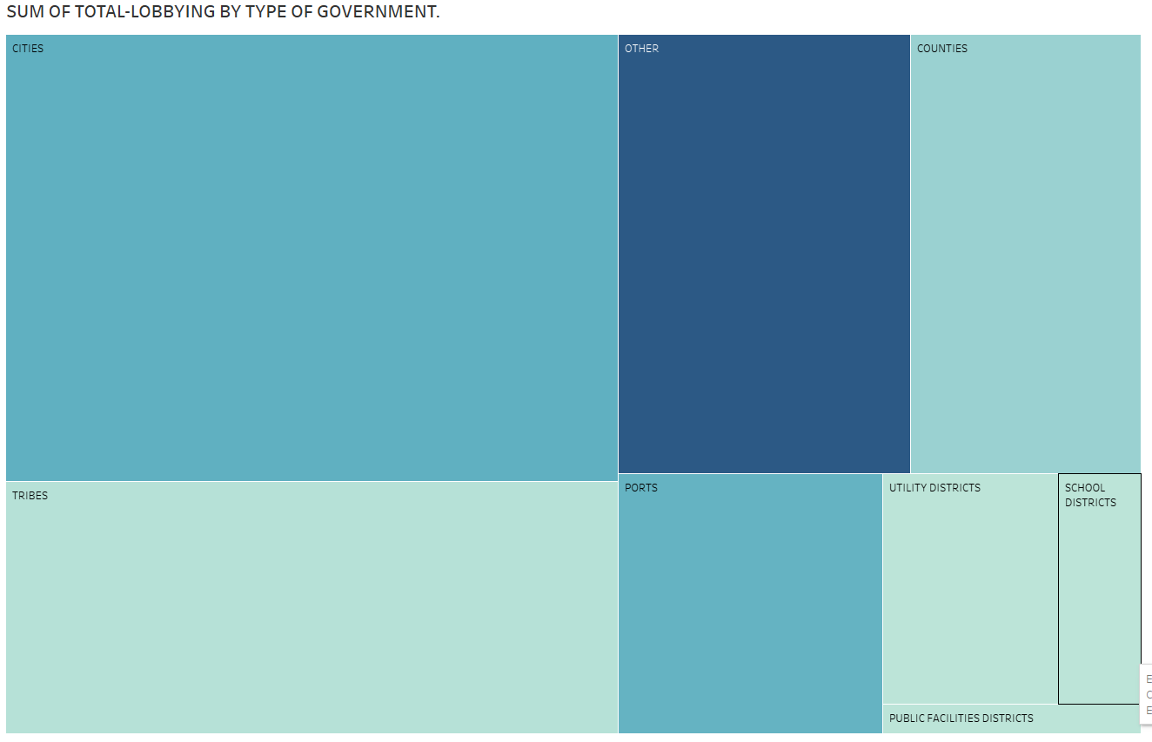

**What did you find out after reviewing the data and creating a treemap?**

The data showed that a large amount of expense used in lobbying was undefined in a category of "Other" which spent $102,702. lobbying for "Tribes" was the smallest expense spending $2,869 while in "cities" and "ports" a significant amount of resources was spent from $38,000 to $40,000. The data showed that public faculties spending was approximately $73, school districts were $0, utility districts $257 and counties is $14,489.

**Based on these findings, what other questions would you want to answer?**

I would like to know as a reporter, what the "Other" column indeed was? $102,702 was spent basically in an undefined category. being this is lobbyist funding for a state capitol, projects. I would assume the money is taxpayer-funded. Therefore, more detail into the usage of this money should be accounted for in more detail than some basic under described category. I would also like to know what more of the resources were designated to categories such as "Other" than nearly all the other categories combined? why were no resources allocated to school districts? Why was less than $300 only used on public utility and facility districts?

**What calculations could you create that would inform your reporting?**

Using descriptive statistics and normal distribution to calculate the deviations of resources allocated in part for overall lobbying efforts would give good insight to inform my reporting. Also, the data with the compensations and expenses could be used for predictive analysis to determine lobbyist budgets for future campaigns.